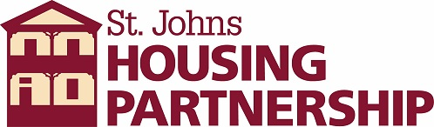
MEDIA RELEASE

For Immediate Release
For further information contact:
Mike Bonts Public Relations
mike@bontspr.com
(904) 424-6641

St. Johns Housing Partnership Accepting Applications for
HUD Housing Counseling Intake Coordinator, Receptionist

ST. AUGUSTINE, Fla. (October 11, 2021) - The St. Johns Housing Partnership (SJHP), creating safe, clean, affordable housing in North Florida since 1996, has an opening for an HUD Housing Counseling Intake Coordinator, Receptionist.

The position consists of working with the non- profit St. Johns Housing Partnership in a strong team environment on Orange Street in St. Augustine, Fla.

The St. Johns Housing Partnership administers government programs to distressed homeowners.

Candidate will assist the Program Director with all aspects of the intake process, including receipt and tracking of outgoing documents, preparing and maintaining client files, answering phone and directing incoming calls, recording and distribution of messages, building and maintaining workshop attendance and documentation, etc.

This position requires flexibility of job tasks, and a courteous, professional, manner to encourage people to access our services.

Familiarity with financial documents, including mortgages and banking paperwork is required. Computer literacy is also a requirement, including word processing and database entry skills.

The St. Johns Housing Partnership is committed to promoting safe, decent and affordable housing in North Florida. They do this by creating links between the public and private sectors on projects that create low- and moderate-income housing, rebuild neglected homes and neighborhoods, thus benefiting disadvantaged areas and enhancing community economic and social development.

Call (904) 824-0902 or email info@sjhp.org for more information.

ABOUT THE ST. JOHNS HOUSING PARTNERSHIP
Founded in 1996 the St. Johns Housing Partnership (SJHP) is committed to providing safe, decent, and affordable housing in North Florida. SJHP creates partnerships between public and private sectors including investors on projects that create low- and moderate-income housing, rebuilds neglected homes and revitalizes neighborhoods in disadvantaged areas while supporting programs that enhance community economic and social development including counselling on homeownership and finances. For more information visit www.sjhp.org.

